User Feedback

Ryan Culhane, 4/30/18 11:45 p.m.

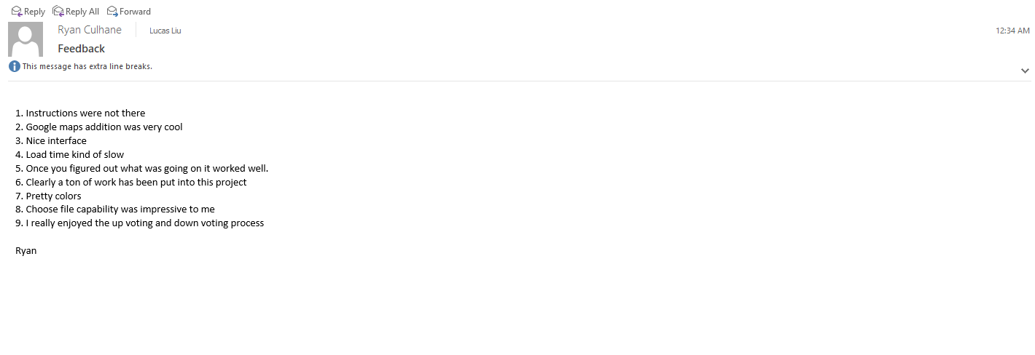

Aditya Mathur 4/30 12:01 a.m.

